**Login Page.**

Once you are on the website and you have not logged in yet, the page will show the “Login Page”, where you must enter a valid username and password.

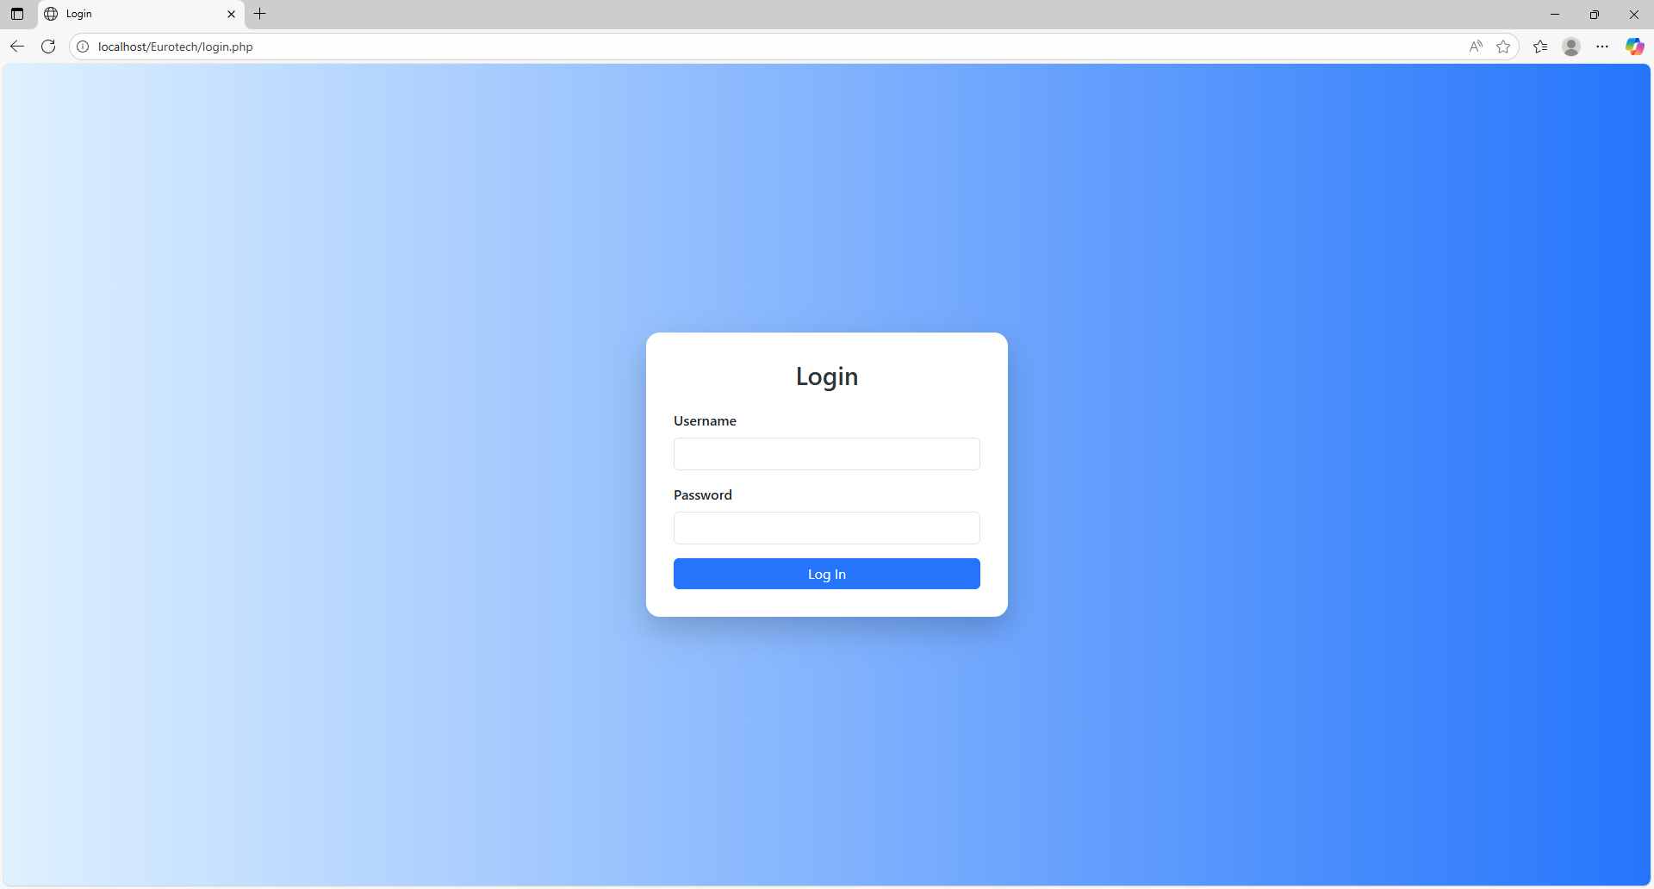

**Home Page.**

If you log in with a valid user, you will be sent to the “Home Page”, that shows you a welcome message and the purpose of the web site. Depending on your user’s role, it will show different options in the navigation bar that is at the top of the page.

If you log in with a user that have the role “Administrator”, you will have permissions to navigate into the pages “Customers”, “Customers PN”, “Customers PPAP Number”, “PPAP’s”, “BluSeal”, “Cables”, “Tapes”, “Tubes”, ”Products”, “Users” and “Vendors” with the options that are at the top of the page.

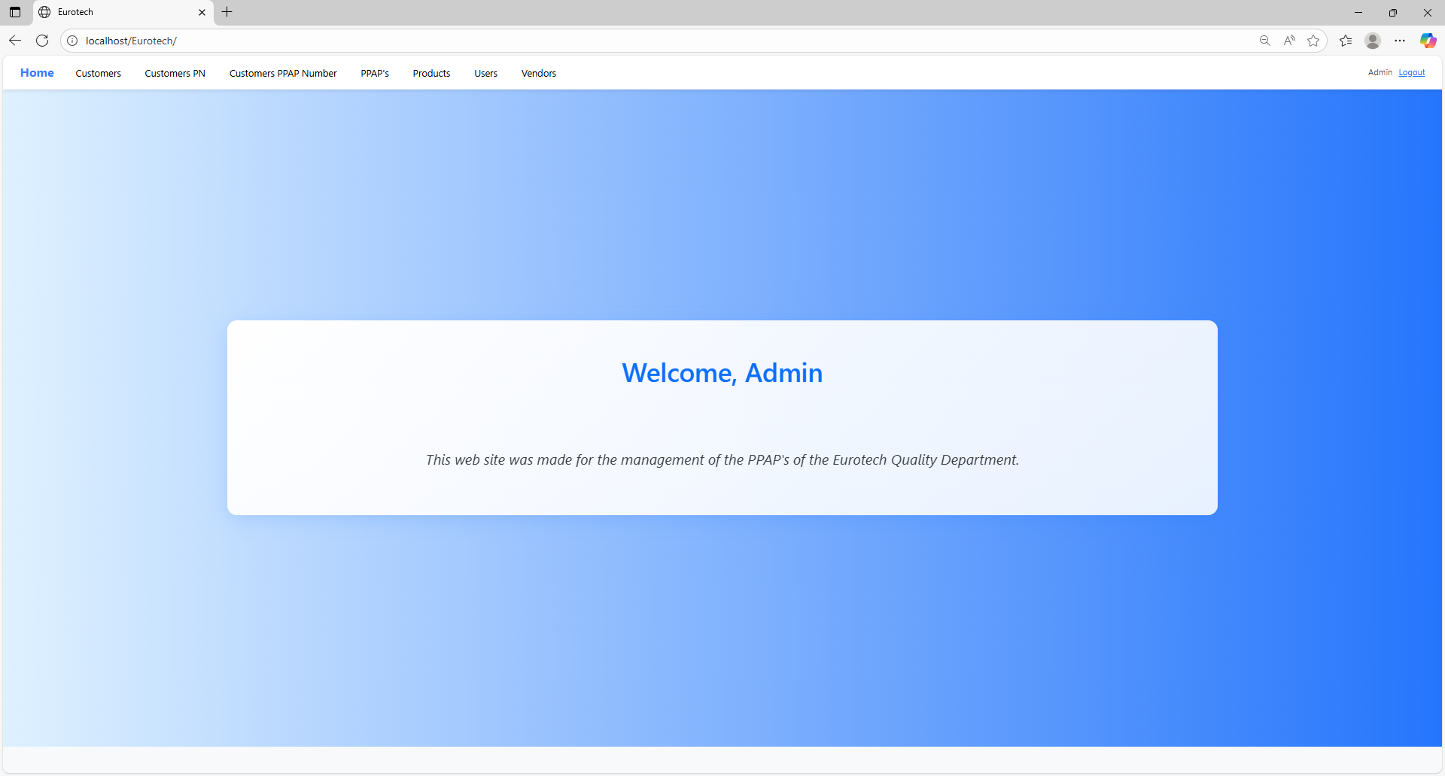

If you log in with a user that have the role “User”, you will only have permissions to navigate into the pages “PPAP’s”, “BluSeal”, “Cables”, “Tapes” and “Tubes” with the options that are at the top of the page.

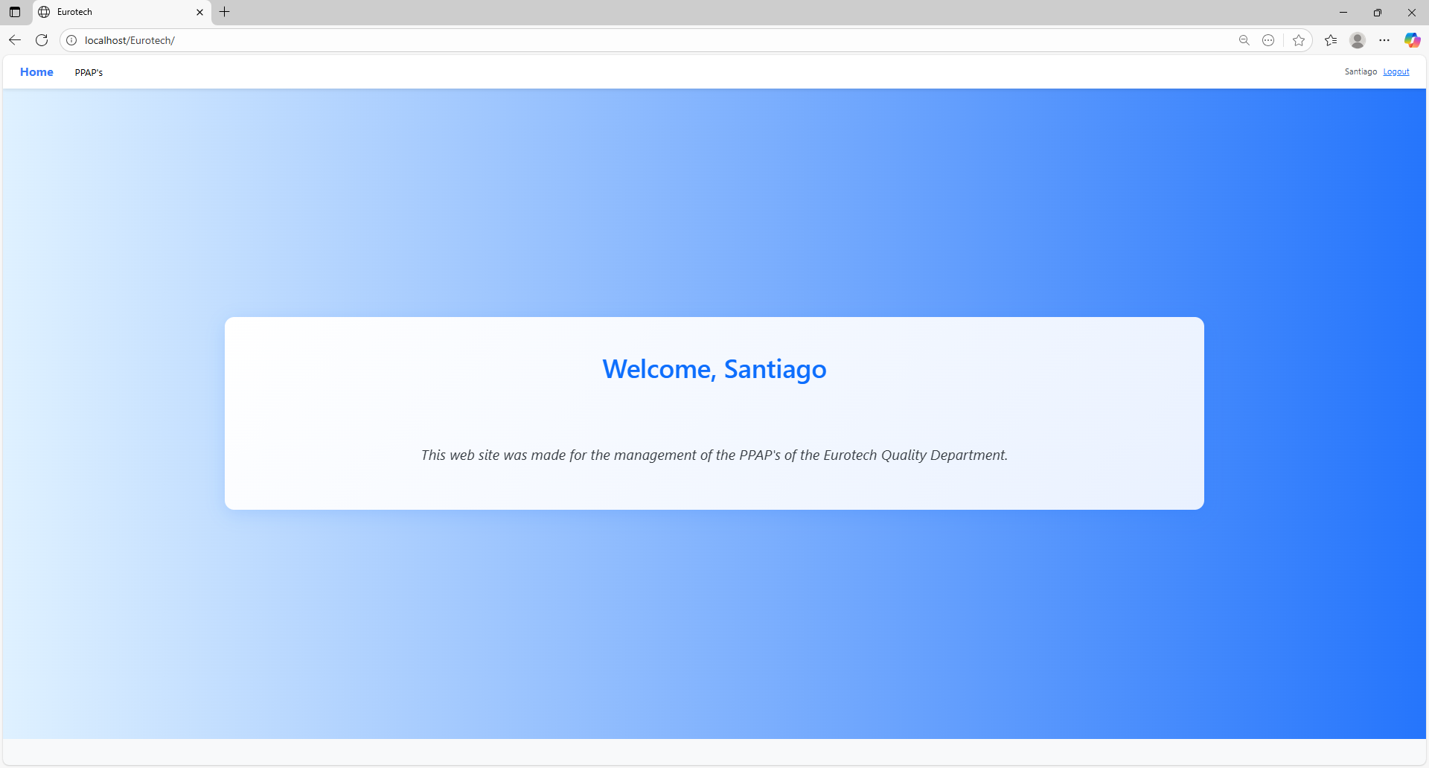

**Users with the role “Administrator”.**

***- Customers Page.***

On the navigation bar, you can navigate to the “Customers Page”.

In this page you can manage the registers of all the customers.

*Search Form.*

At the top of the page, it will be a dropdown “Search Form” that has all the fields of the table for querying registers.

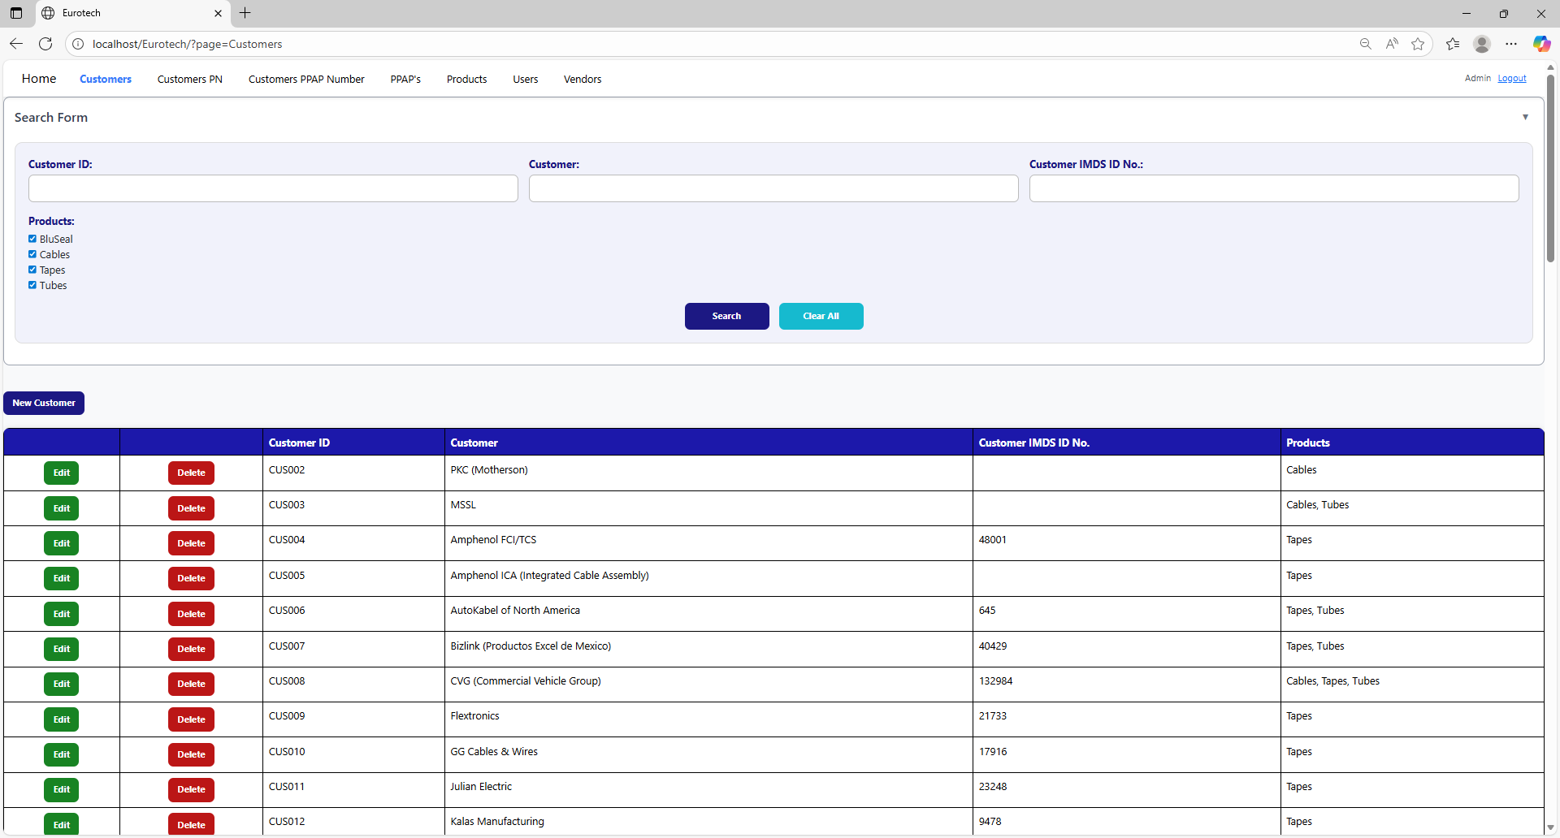

You can search by “Customer ID”, using the “Customer ID” field and clicking the “Search” button.

You can search by “Customer”, using the “Customer” field and clicking the “Search” button.

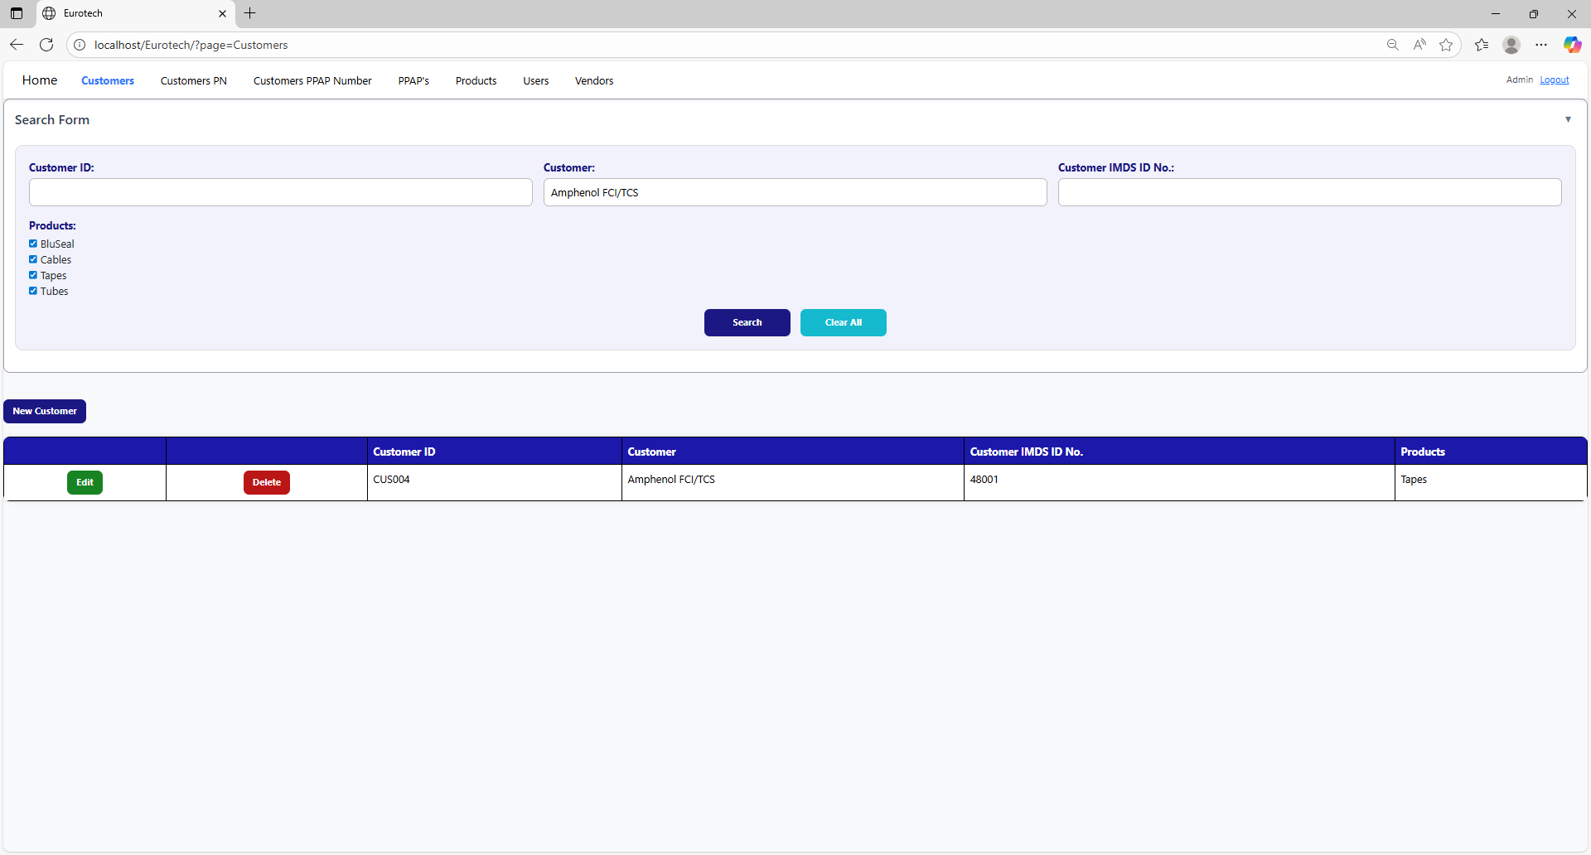

You can search by “Customer IMDS ID No.”, using the “Customer IMDS ID No.” field and clicking the “Search” button.

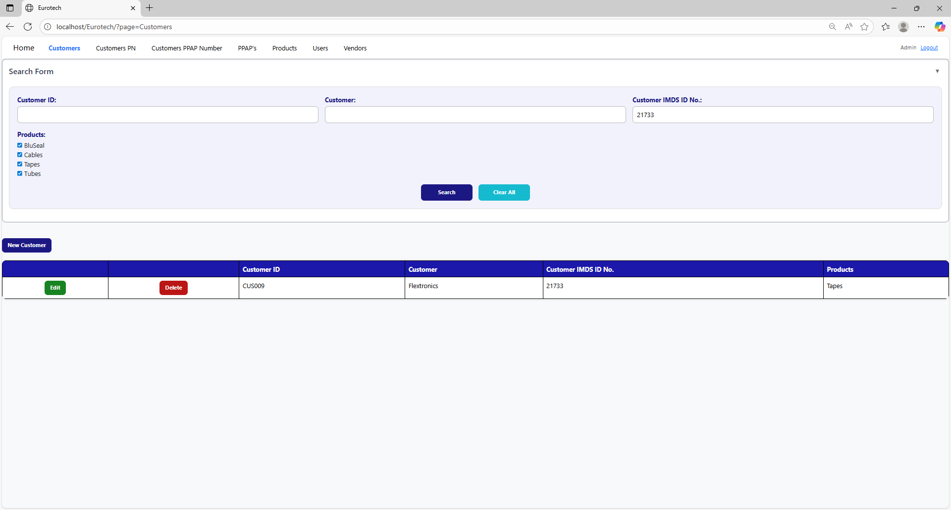

You can search by “Products” (this means the products of the PPAPs that will be realize for the customers), using the “Products” field and clicking the “Search” button.

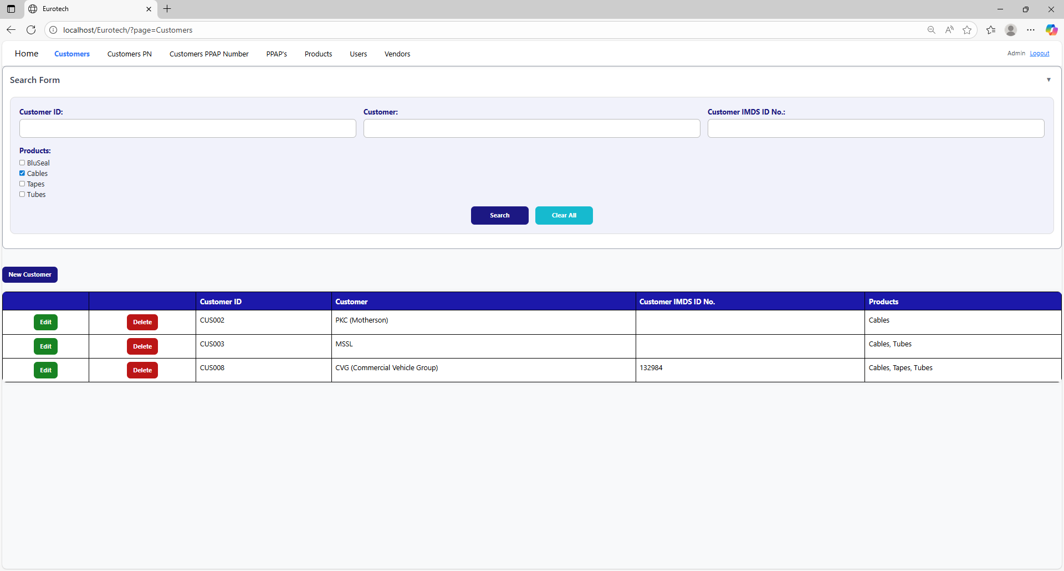

And with the “Clear All” button, you can clean the querying and see all the registers of the customers.

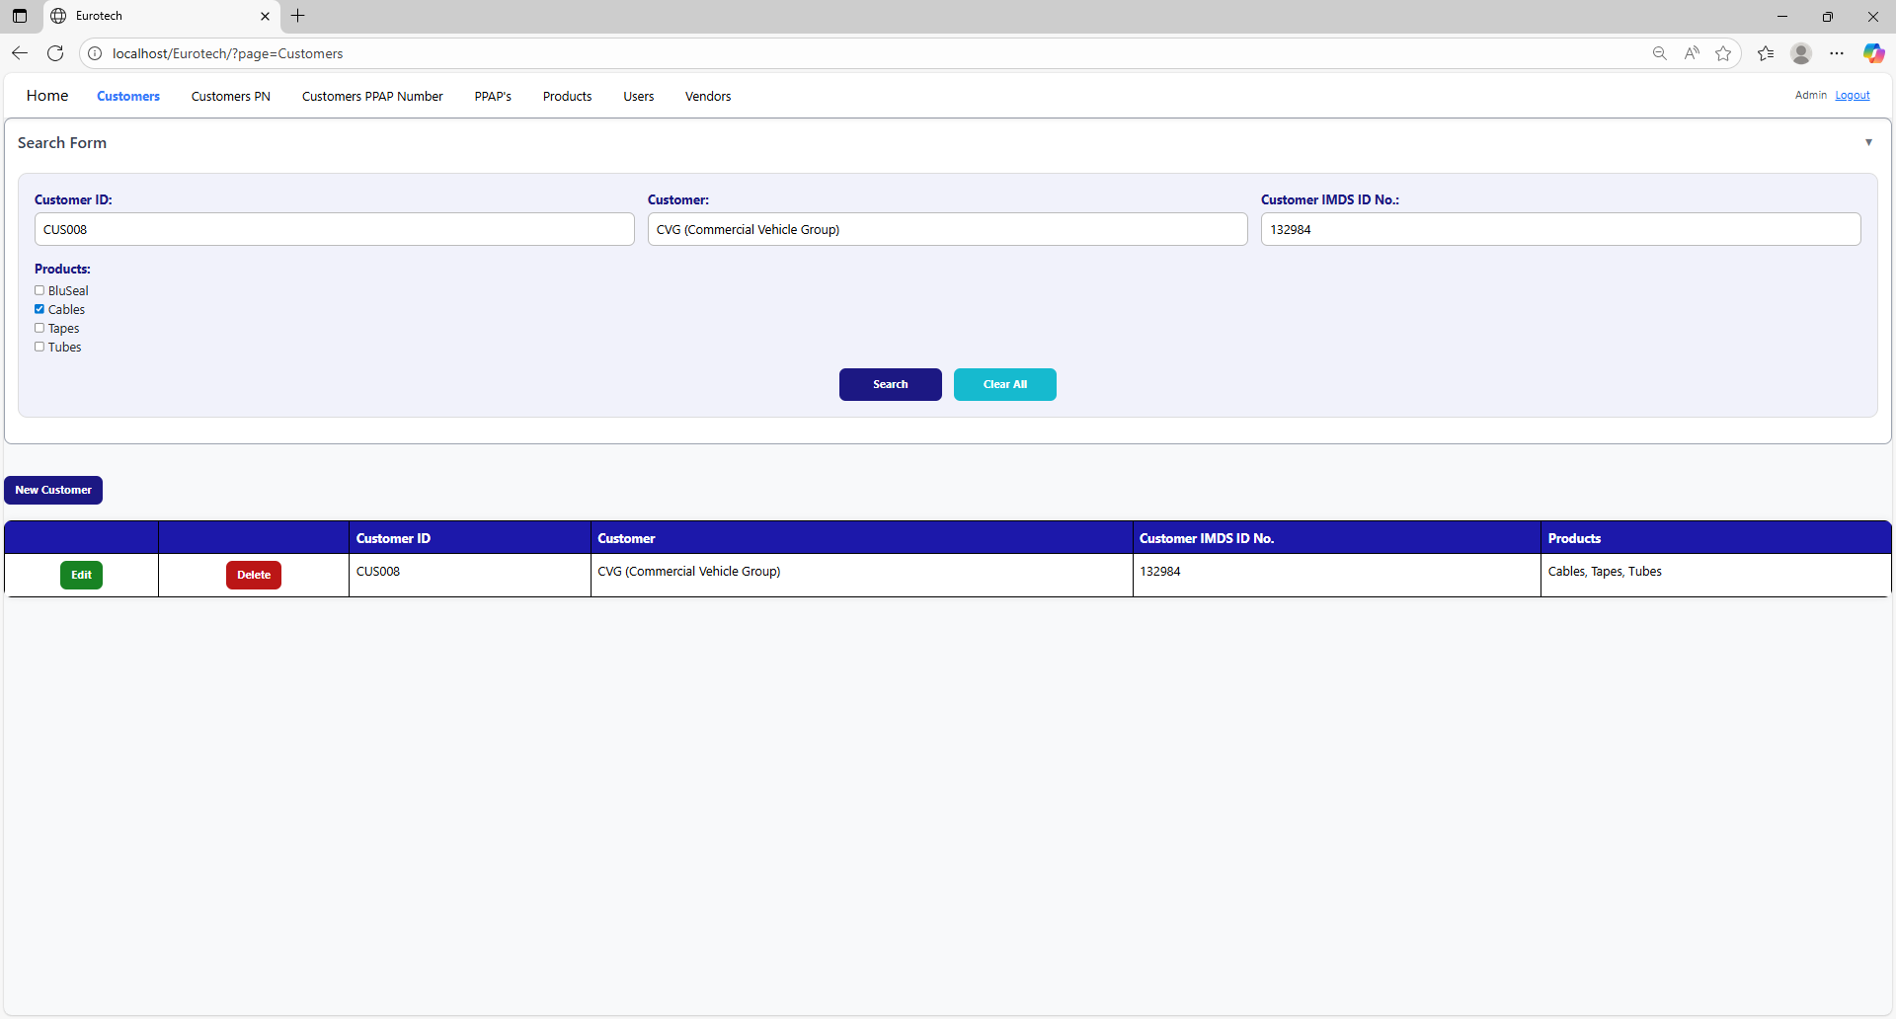



*New Customer.*

Below the “Search Form”, it is the “New Customer” button. If this button is clicked, it will display a register form to create a new customer.

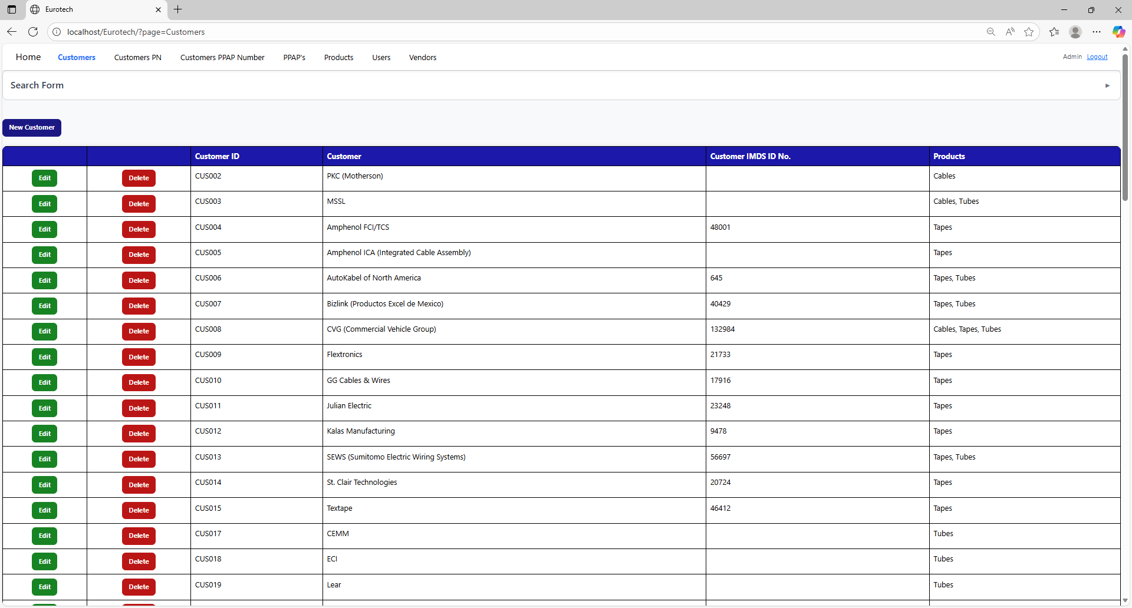

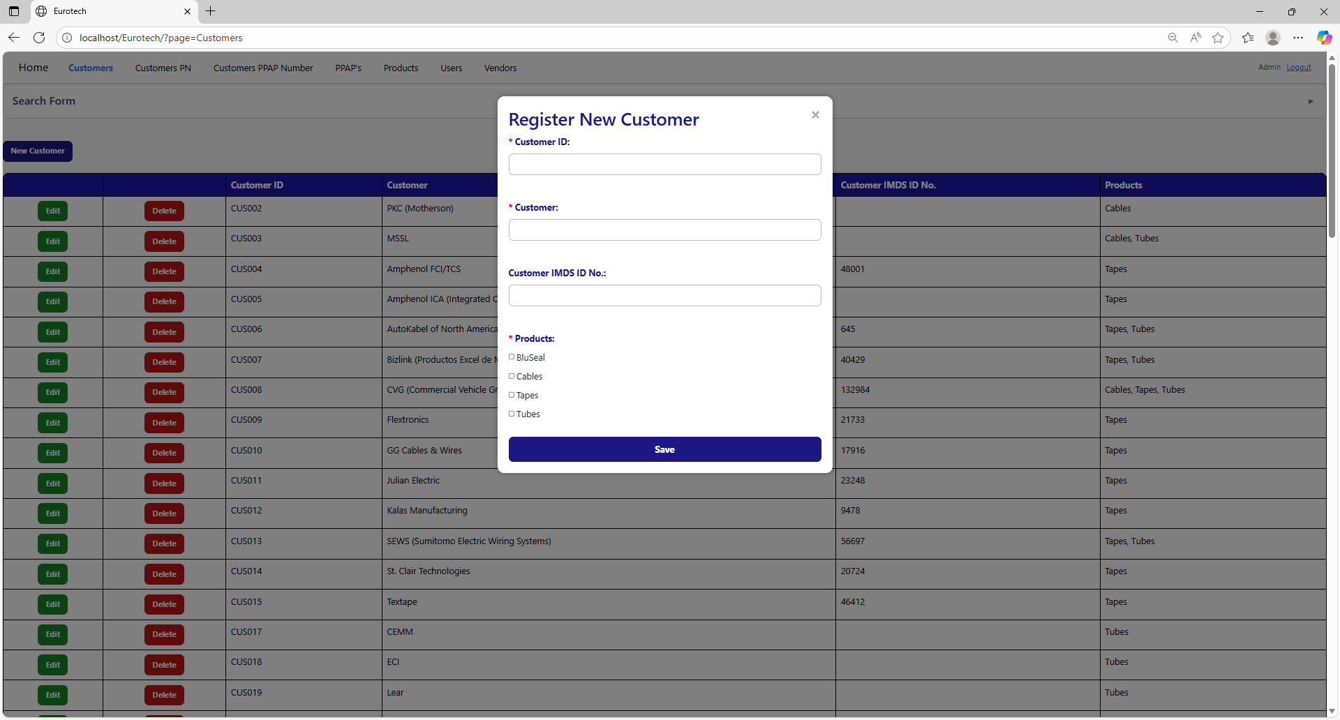

The register form has the “Customer ID”, “Customer” and “Products” fields as mandatories, and the “Customer IMDS ID No.” field that isn’t mandatory. You can’t duplicate the “Customer ID”, “Customer” or the “Customer IMDS ID No.” from a register that already exists in the database.

If you want to save the register of a new customer, you must click the “Save” button.

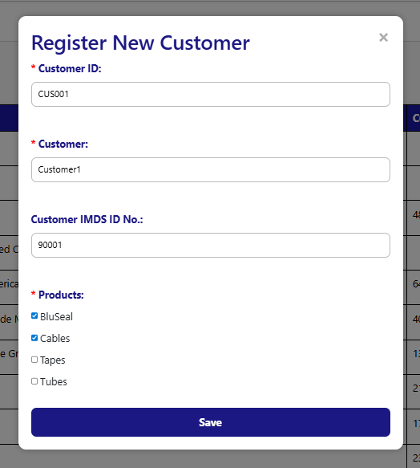

*Edit.*

In each register from the table, it will be an “Edit” button. If this button is clicked, it will display an update form to edit the information of the selected customer.



To save the changes, you must click the “Save” button.

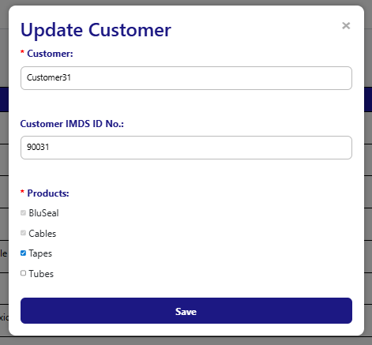

*Delete.*

In each register from the table, it will be a “Delete” button. If this button is clicked, it will display the information of the selected customer with a message to confirm the delete action.



To confirm the delete action, you must click the “Confirm” button. It only deletes customers that doesn’t have registers in “Customer PN”, “Customer PPAP Number” and “PPAP’s”.

***- Customers PN Page.***

On the navigation bar, you can navigate to the “Customers PN Page”.

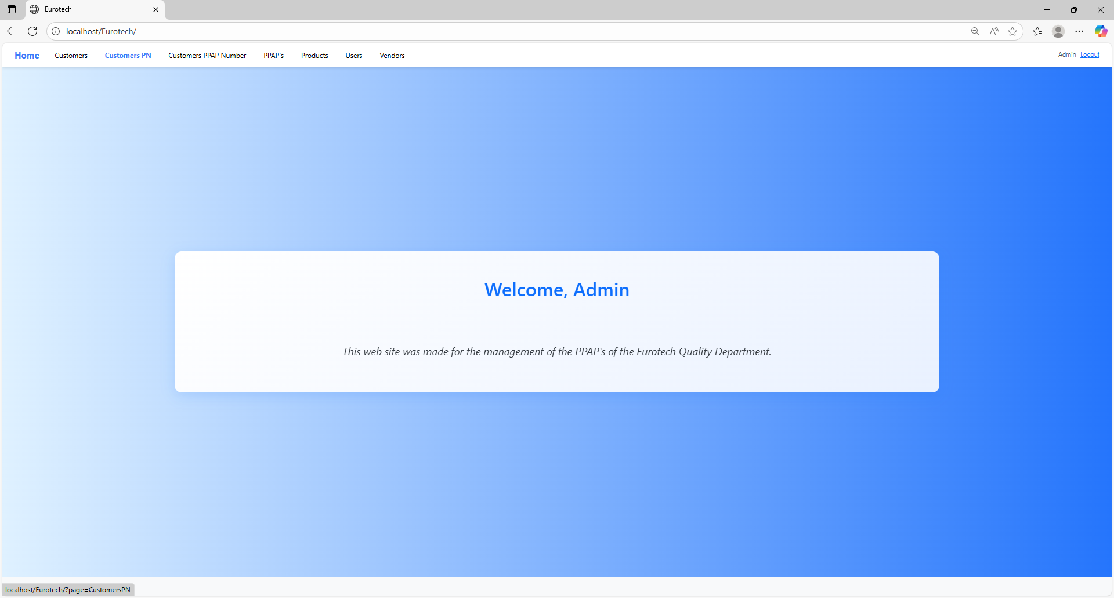

In this page you can manage the registers of all the Customer PN.

*Search Form.*

At the top of the page, it will be a dropdown “Search Form” that has all the fields of the table for querying registers.

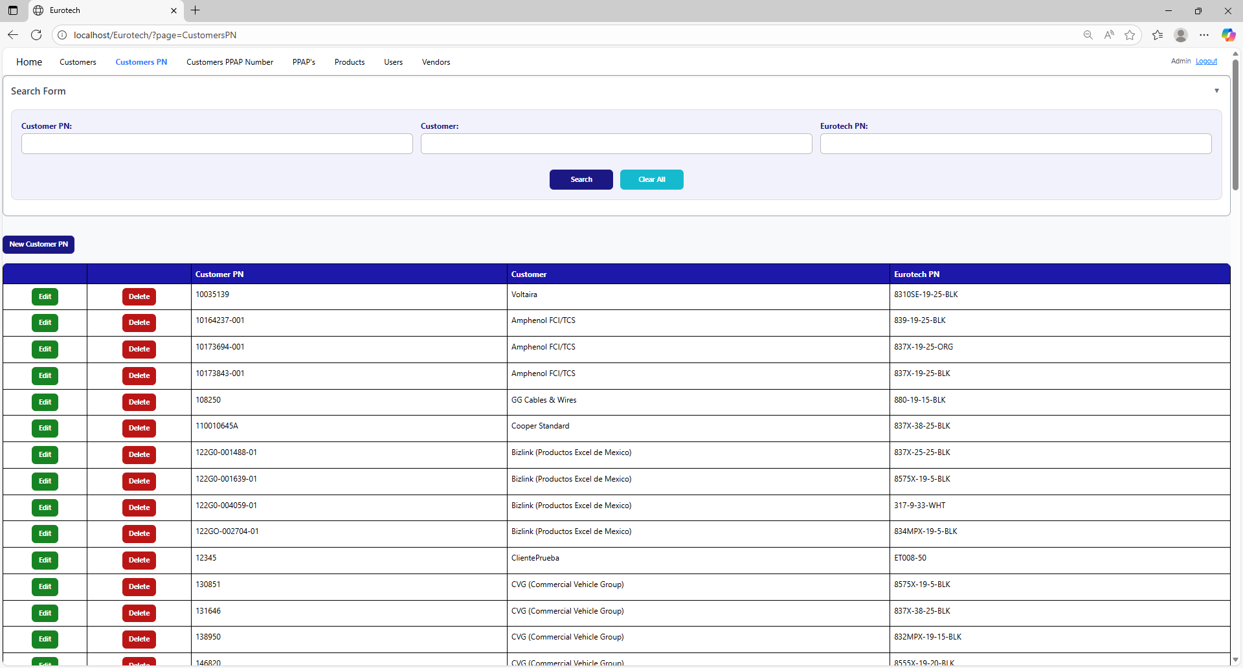

You can search by “Customer PN”, using the “Customer PN” field and clicking the “Search” button.

You can search by “Customer”, using the “Customer” field and clicking the “Search” button.

You can search by “Eurotech PN”, using the “Eurotech PN” field and clicking the “Search” button.

And with the “Clear All” button, you can clean the querying and see all the registers of the Customer PN.

*New Customer PN.*

Below the “Search Form”, it is the “New Customer PN” button. If this button is clicked, it will display a register form to create a new Customer PN.

The register form has the “Customer PN”, “Customer” and “Eurotech PN” fields as mandatories. You can’t duplicate a register that already exists in the database.

If you want to save the register of a new Customer PN, you must click the “Save” button.

*Edit.*

In each register from the table, it will be an “Edit” button. If this button is clicked, it will display an update form to edit the information of the selected Customer PN.

To save the changes, you must click the “Save” button.

*Delete.*

In each register from the table, it will be a “Delete” button. If this button is clicked, it will display the information of the selected Customer PN with a message to confirm the delete action.

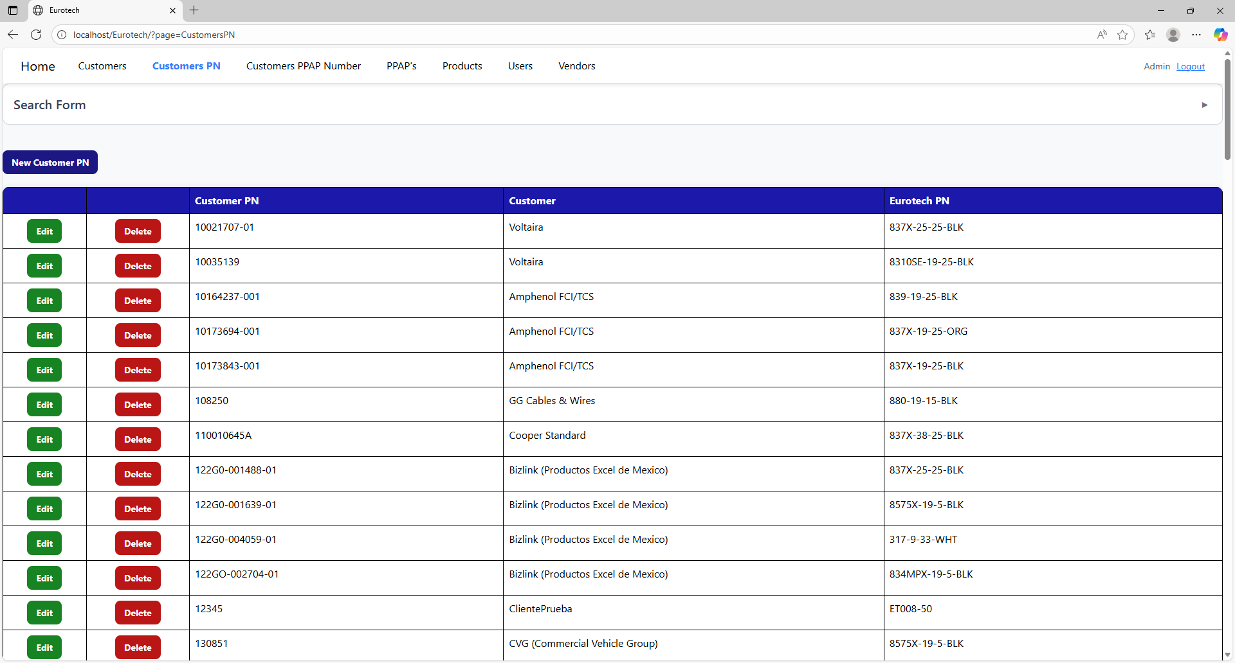

To confirm the delete action, you must click the “Confirm” button. It only deletes Customer PN that doesn’t have registers in “PPAP’s”.

***- Customers PPAP Number Page.***

On the navigation bar, you can navigate to the “Customers PPAP Number Page”.

In this page you can manage the registers of all the Customer PPAP Number.

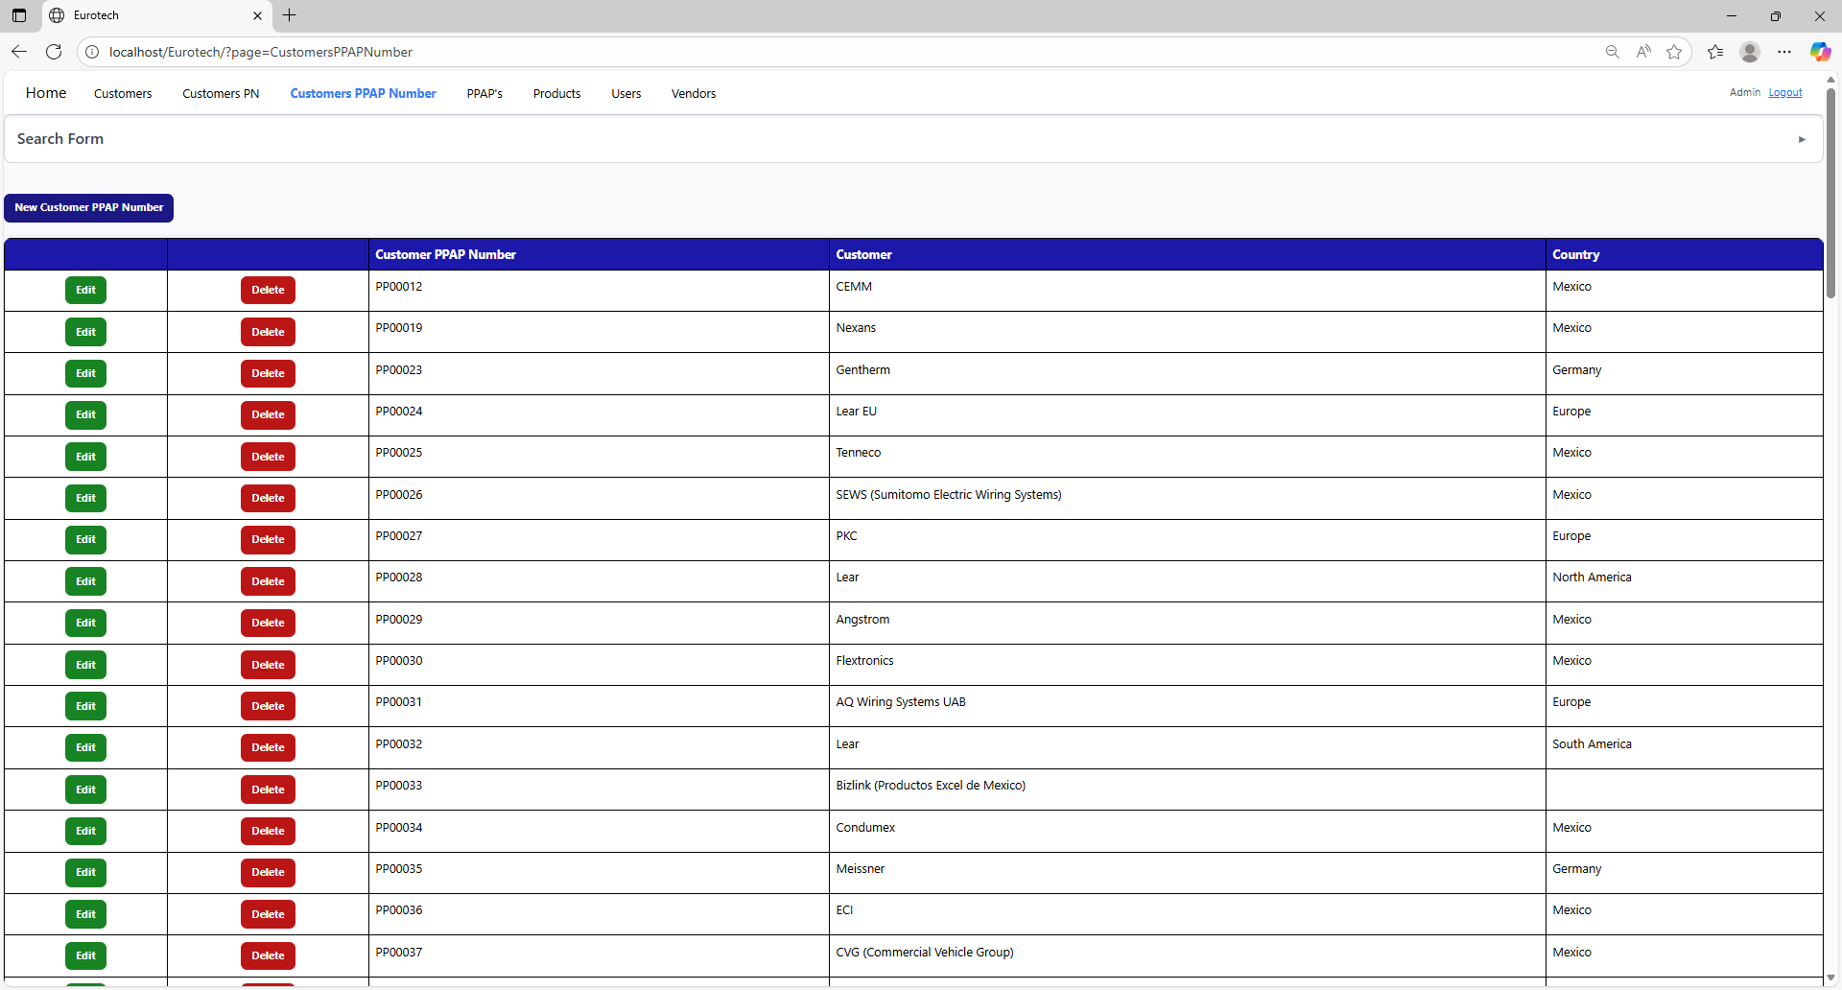

*Search Form.*

At the top of the page, it will be a dropdown “Search Form” that has all the fields of the table for querying registers.

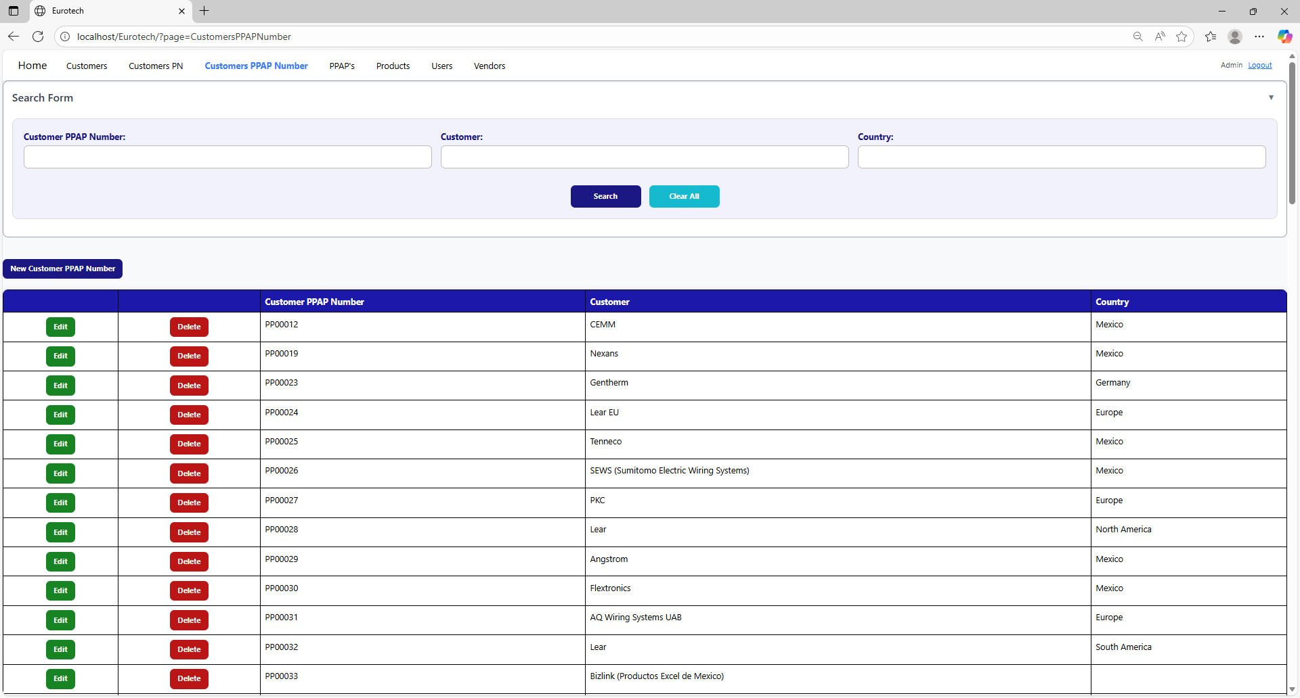

You can search by “Customer PPAP Number”, using the “Customer PPAP Number” field and clicking the “Search” button.

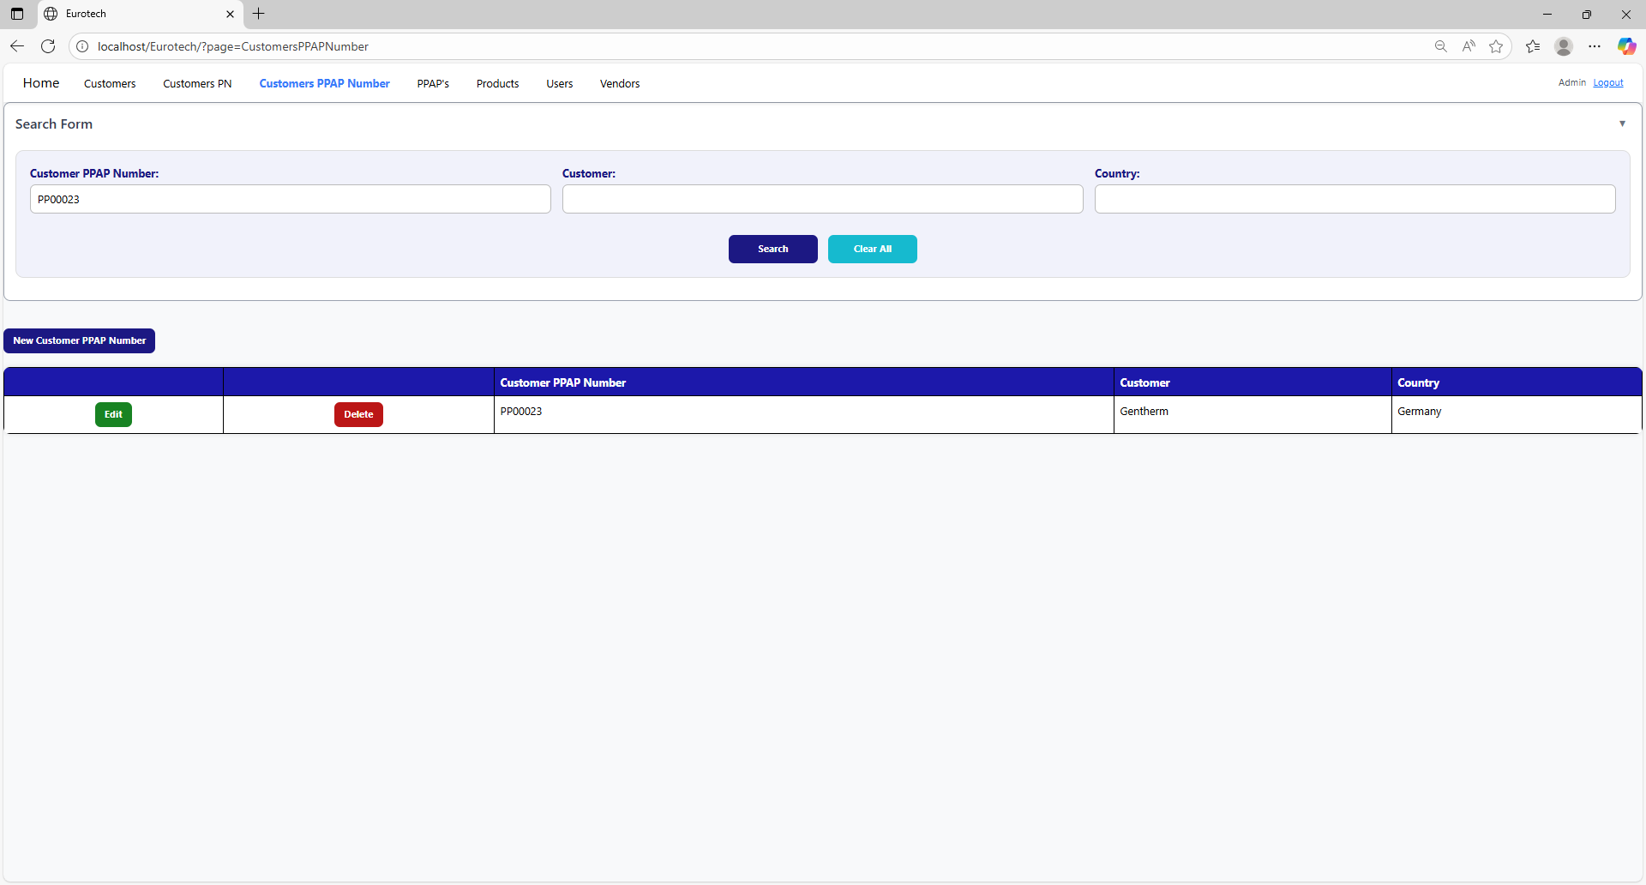

You can search by “Customer”, using the “Customer” field and clicking the “Search” button.

You can search by “Country”, using the “Country” field and clicking the “Search” button.

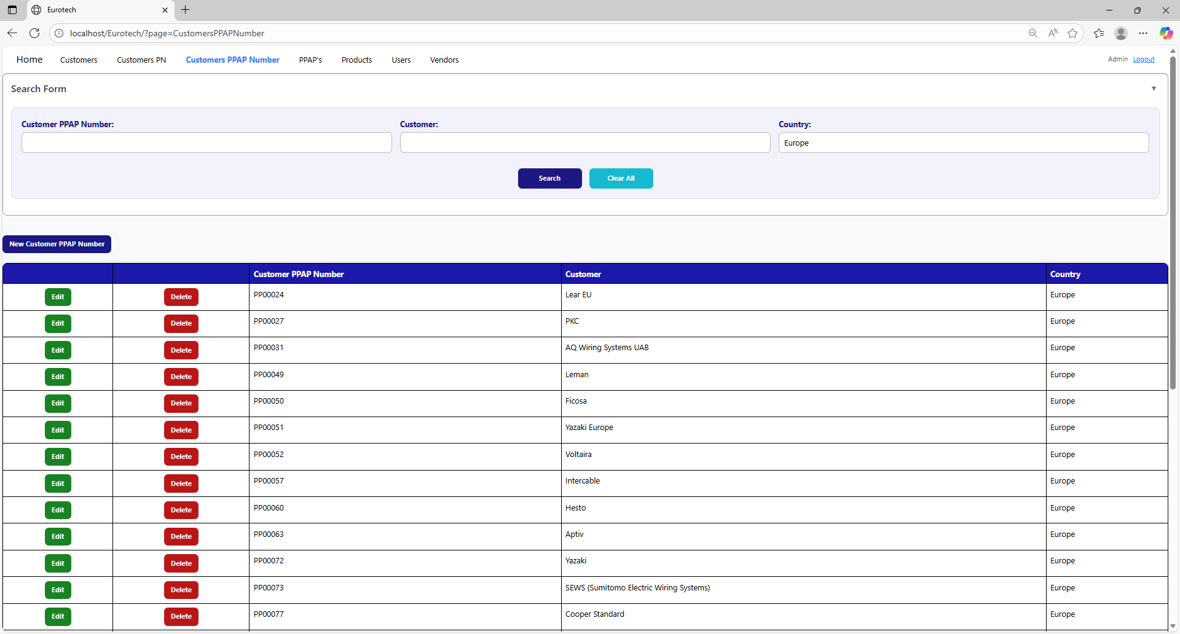

And with the “Clear All” button, you can clean the querying and see all the registers of the Customer PPAP Number.

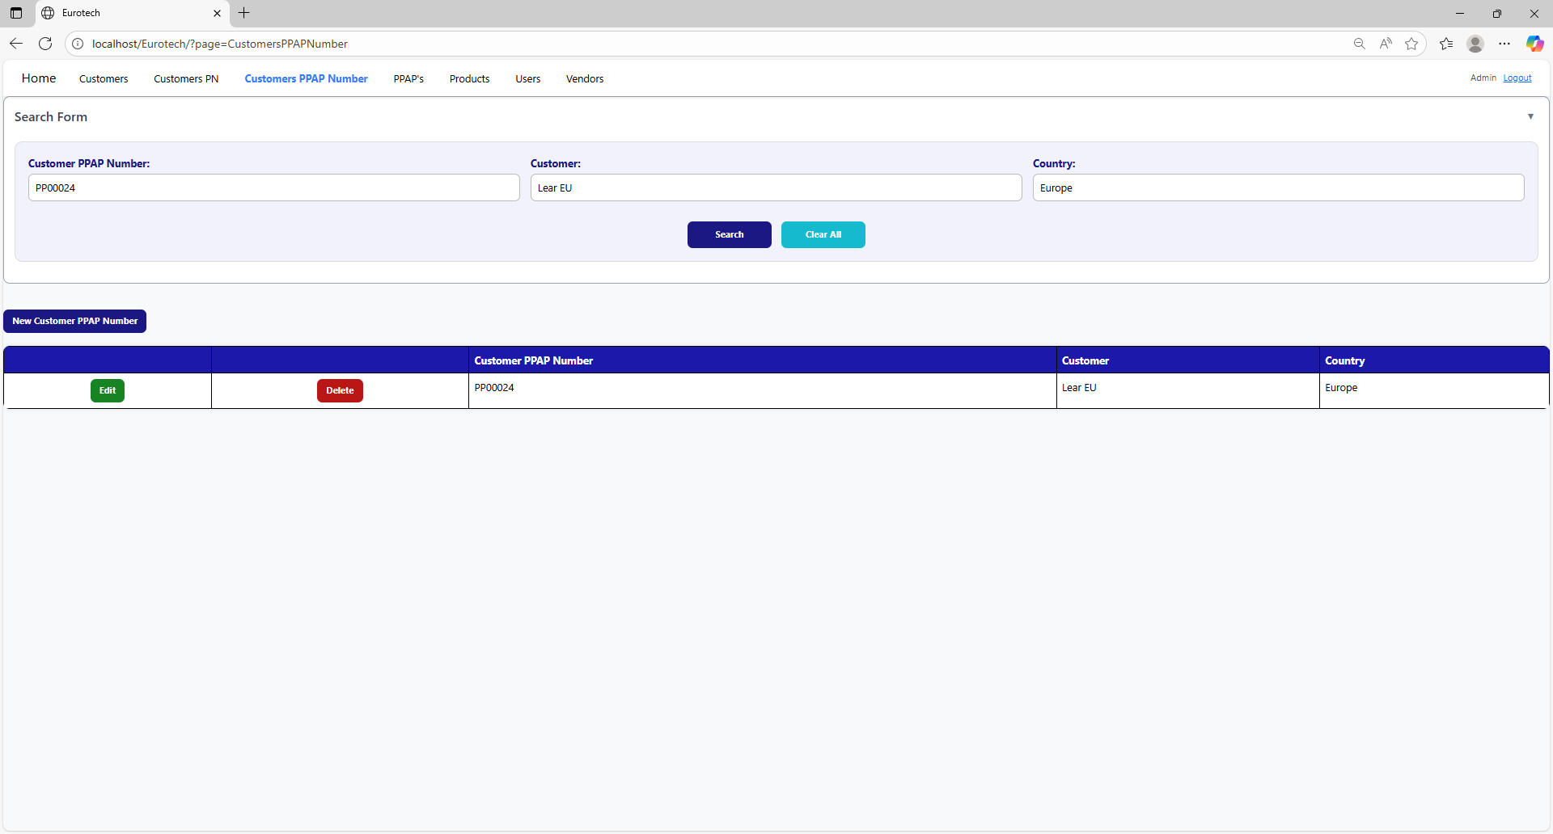

*New Customer PPAP Number.*

Below the “Search Form”, it is the “New Customer PPAP Number” button. If this button is clicked, it will display a register form to create a new Customer PPAP Number.

The register form has the “Customer PPAP Number”, “Customer” fields as mandatories, and the “Country” field that isn’t mandatory. You can’t duplicate a register that already exists in the database.

If you want to save the register of a new Customer PPAP Number, you must click the “Save” button.

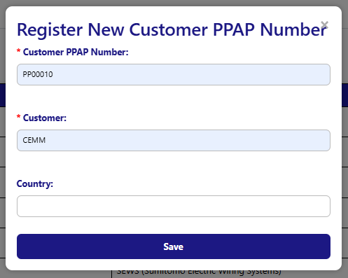

*Edit.*

In each register from the table, it will be an “Edit” button. If this button is clicked, it will display an update form to edit the information of the selected Customer PPAP Number.

To save the changes, you must click the “Save” button.

*Delete.*

In each register from the table, it will be a “Delete” button. If this button is clicked, it will display the information of the selected Customer PN with a message to confirm the delete action.

To confirm the delete action, you must click the “Confirm” button.

***- PPAP’s Page.***

***- BluSeal Page.***

***- Cables Page.***

***- Tapes Page.***

***- Tubes Page.***

***- Products Page.***

On the navigation bar, you can navigate to the “Products Page”.

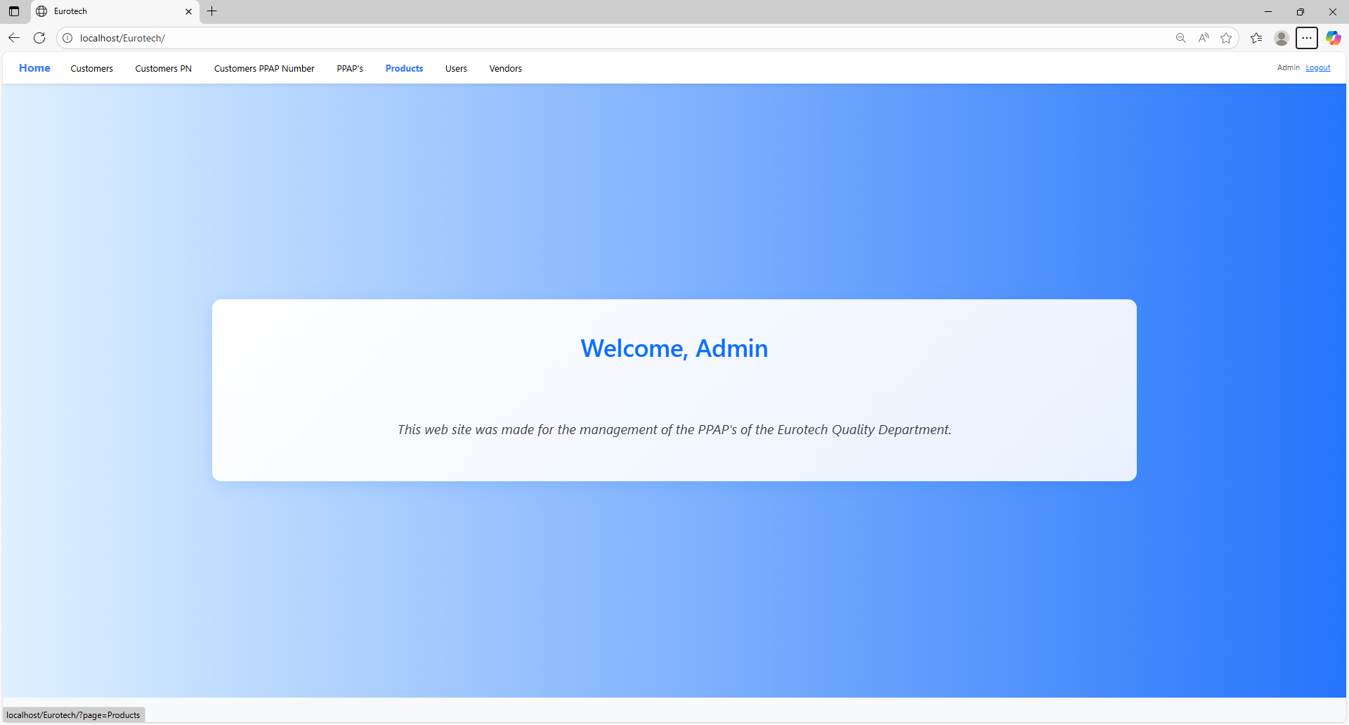

In this page you can manage the registers of all the products.

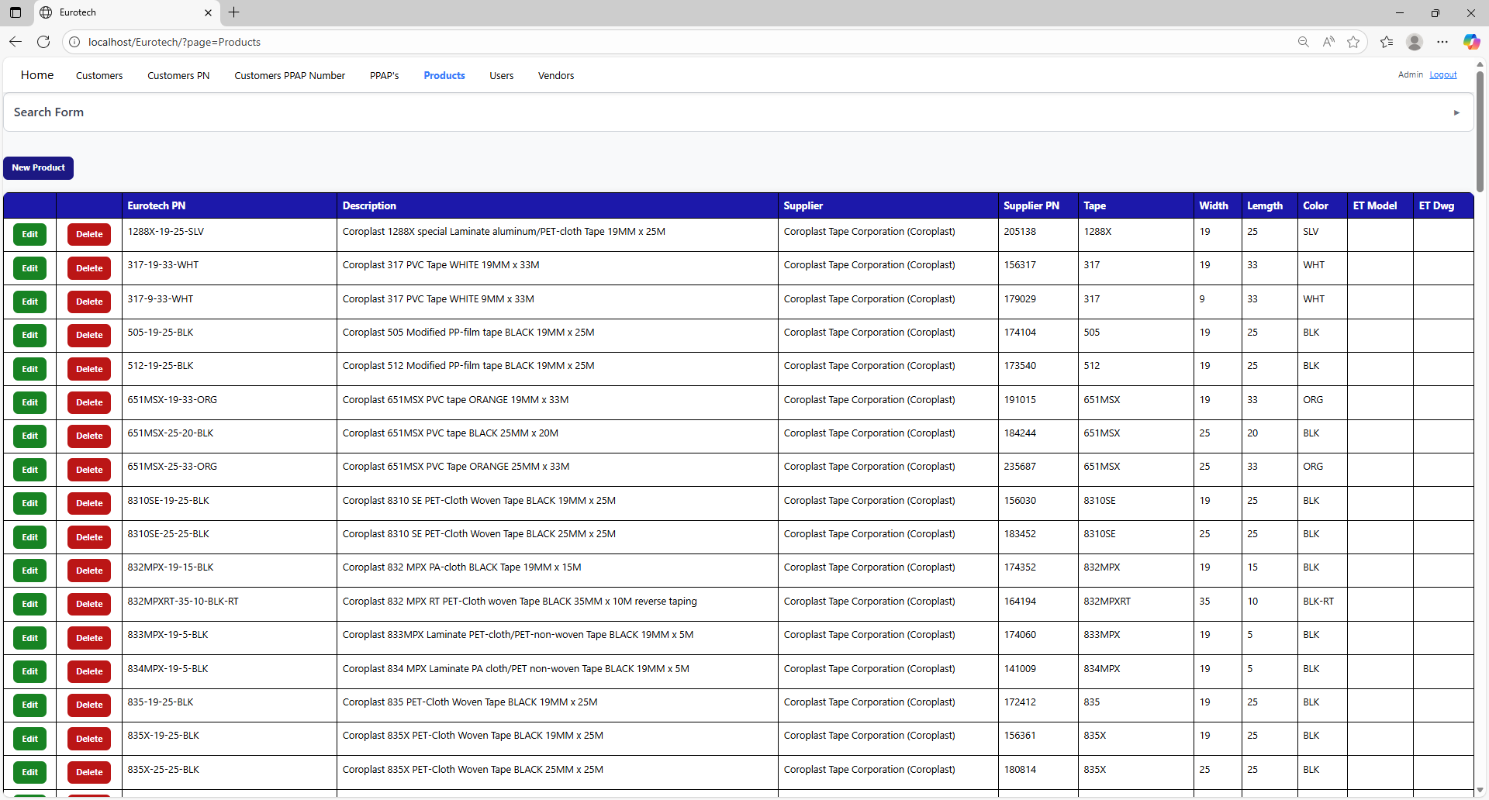

*Search Form.*

At the top of the page, it will be a dropdown “Search Form” that has all the fields of the table for querying registers.

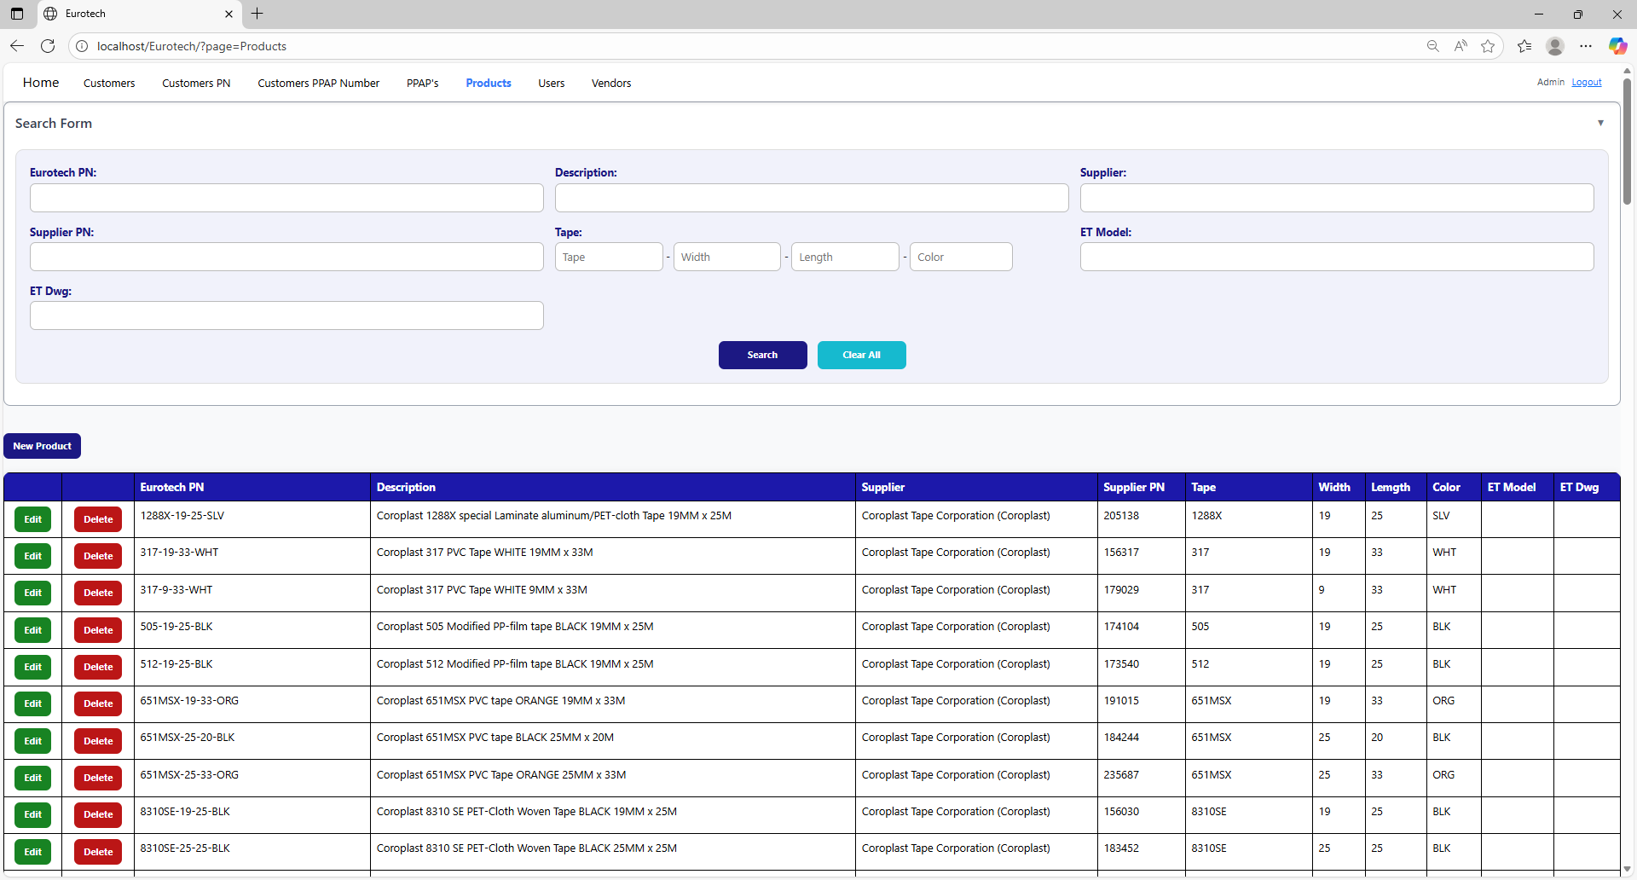

You can search by “Eurotech PN”, using the “Eurotech PN” field and clicking the “Search” button.

You can search by “Description”, using the “Description” field and clicking the “Search” button.

You can search by “Supplier”, using the “Supplier” field and clicking the “Search” button.

You can search by “Supplier”, using the “Supplier” field and clicking the “Search” button.

You can search by “Tape”, using the “Tape” field and clicking the “Search” button.

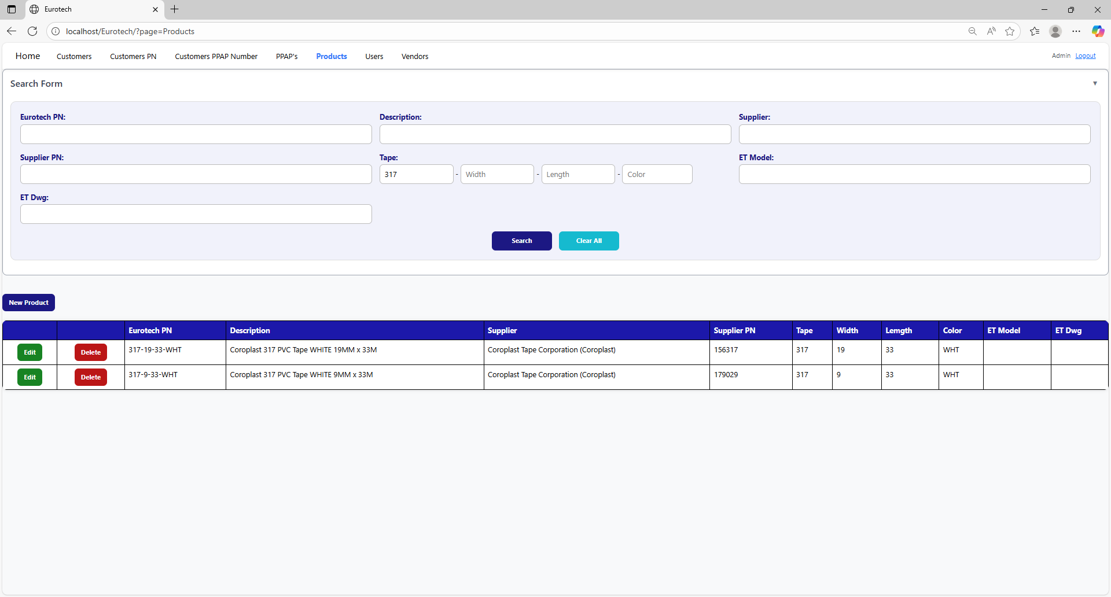

You can search by “Width”, using the “Width” field and clicking the “Search” button.

You can search by “Length”, using the “Length” field and clicking the “Search” button.

You can search by “Color”, using the “Color” field and clicking the “Search” button.

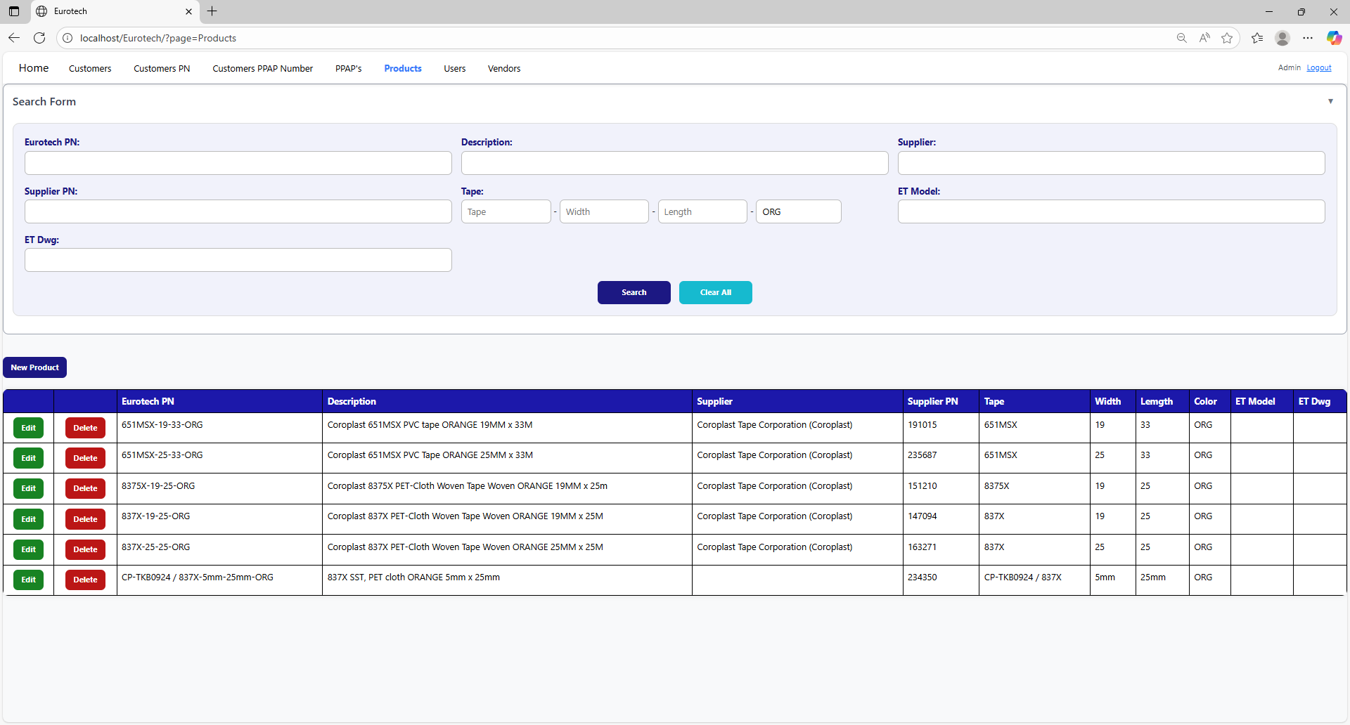

And with the “Clear All” button, you can clean the querying and see all the registers of the Customer PPAP Number.



**Users with the role “User”**